Project Development Phase
Model Performance Test

Date | 30 August 2026
Project Name | Automated Network Request Management in ServiceNow
Maximum Marks

Model Performance Testing:

S.No. | Parameter | Values | Screenshot
 | System Summary | ServiceNow-based network request management system that allows employees to submit network-related requests through the Service Catalog and automates request processing, record creation, approval, status updates, and notifications using Flow Designer. | 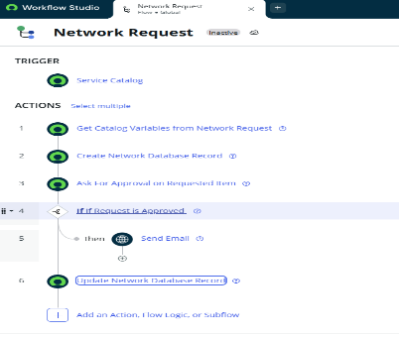
 | Request Submission Performance | Successful – Employee can enter the required network request information and submit the request successfully through the Service Catalog. | 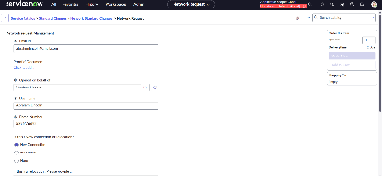
3. | Request Record Creation | Successful – After submission, the configured Flow Designer process creates the corresponding Network Request record and stores the submitted information correctly. | 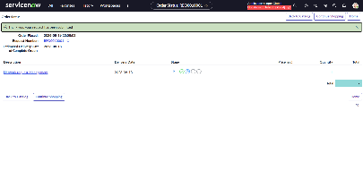
4. | Dynamic Form Performance | Successful – Relevant fields are displayed based on the selected request or device option, allowing users to provide the required information. | 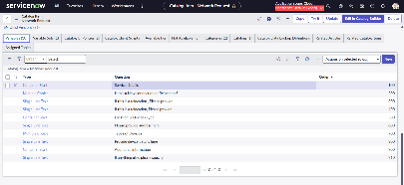
5. | Approval Automation | Successful – The submitted network request is processed through the configured approval workflow, and the approval decision is recorded. | 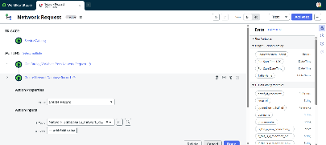
6. | Workflow Automation | Successful – Flow Designer executes the configured request activities, including retrieving request information, creating records, processing approval, and updating the request. | 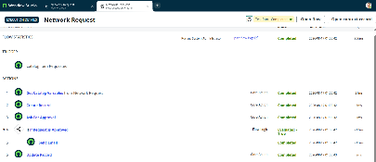
7. | Status Update & Notification | Successful – Request status is updated during processing and the configured email notification is generated with relevant request information. | 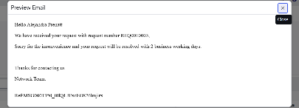
8.. | Overall System Performance | Successful – The complete network request lifecycle executes according to the configured ServiceNow workflow without functional errors during testing. | 

